** Firewood Harvesting Guidelines**

**Disclaimer: Tree cutting, and chainsaw work is inherently dangerous. Consider taking a chainsaw course before harvesting and/or contacting an arborist or forester if you have any doubt about cutting your own trees for firewood.**

For those of you that have identified obtaining forest products from your property including firewood for personal use, this information sheet will clarify what trees can be cut and what trees should be left as they are.

Trees that can be cut

* diseased trees
* damaged trees
* dangerous trees especially near trails and buildings
* trees that have fallen across trails

Trees that should left as they are

* snags or dead standing trees
* trees with natural cavities or wildlife trees
* hard and soft mast trees
* trees on the ground or downed woody debris (DWD)

**Trees That Can Be Cut**

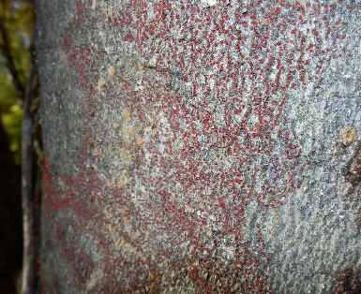**Diseased trees**

A common diseased tree in the Highlands Corridor is American Beech. Beech Bark Disease is caused by the beach scale insect which leaves feeding punctures that kill the living bark, leaving cracks in the bark allowing the damaging fungus to enter. Fungus shows up as small cankers on the bark’s surface, appearing as orange or red fruiting bodies in the fall.

Paul Heaven, 2020. Fruiting bodies of fungal infection

Birch Bark Disease can create die back that is not readily obvious. Upper limbs and trunk breakage can pose serious hazards to the tree cutter.

Target canker is a fungal disease that causes localized death of the tree cambium. Looking like a bull’s eye on the trunk, the tree produces extra wood and callus tissue around the fungus to try to contain it. Over time, this can lead to poor leaf growth, branch die back and even tree death.

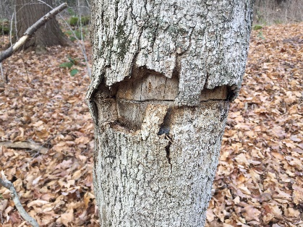**Damaged trees**

Trees with damage are prime candidates for cutting. Common damage for Sugar Maple is from the Maple Borer beetle. This beetle prefers to lay its eggs in the natural crevices of the bark of Sugar Maples. The egg metamorphosizes into a larva that chews its way through the bark into the cambium layer of the tree, leaving tunnel scars surrounded by peeled back bark. Burls, or large, woody growths on trees have proven to be harmless to the tree.

Rick Whitteker, 2021. Maple Borer damage

**Dangerous trees**

Dangerous trees are those that have a significant lean to them, potentially endangering people using the trails or damaging buildings and other structures. These trees can be cut with care.

**Trees across trails**

Trees that have fallen over and block trail access can also be cut.

**Trees That Should Be Left**

**Snags or standing dead trees**

Trees that are dead but are still standing provide vital roles including the following:

* **A Place to Live**—Many animals, including birds, bats, squirrels and raccoons make nests in hollow cavities and crevices in standing deadwood.
* **A Food Source**—By attracting insects, mosses, lichens and fungi, deadwood becomes a gourmet restaurant for wildlife looking for a snack.
* **A "Crow's Nest"**—Higher branches of snags serve as excellent lookouts from which wildlife such as raptors spot potential prey.
* **A Hiding Place**—The nooks and crannies of deadwood are put to good use by squirrels and other wildlife looking to store food.
* **A Soil Enricher**—Mosses, lichens and fungi all grow on snags and aid in the return of vital nutrients to the soil through the nitrogen cycle. Decaying logs on the forest floor also act as "nurse logs" for new seedlings.

**Trees with natural cavities or wildlife trees**

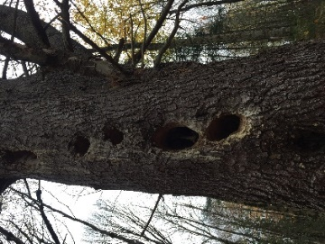Like snags but still living, trees with cavities in them create nesting opportunities for many critters. Trees with cavities at the base of the trunk provide escape zones for prey and resting, safe locations for many small animals.

Trees with obvious signs of wildlife activity should remain standing. Examples might include tree with stick or leaf nests, claw marks on the bark, antler rubs, squirrel middens at their base and chew marks from lagomorphs (rabbits/hare), rodents and deer or moose.

Rick Whitteker, 2018. Pileated Woodpecker excavations in a White Pine tree.

**Hard and soft mast trees**

Beech and oak trees are common hard-mast producers. The collective term for fruit and nuts, mast trees put out high volumes of nuts every 2-8 years. For example, Red Oaks produce acorns every year but, in some years, they produce a bumper crop of acorns which is very high compared to a typical year’s output. These are called mast years. Acorns are an important source of food for deer, squirrels, jays, woodpeckers and many other animals.

Soft mass trees such as Black Cherry should also be left standing.

**Downed woody debris**

Trees and other woody debris on the ground provide significant ecological value to the environment. Dead wood adds organic matter to the soil, stores carbon, provides habitat for decomposer organisms, provides sites for wildlife dens, nests and burrows and hiding cover for predators and escape cover for prey just to name a few ecological rolls of down debris. Ultimately, down debris increases biodiversity. Pick diseased trees over downed trees for your firewood needs.

Finally, consider the importance of your forest diversity.  Don’t remove all of one species.  Maintain diversity, even if the trees are not in perfect health. For example, trees like diseased Butternut should be left standing in the hopes of potential of seed germination and sampling recruitment.